CS3600 Spring 2021 **HW 4-3600 Operating System**

**Submit your answers in Canvas as a pdf document on or before (04/18/2021).**

**Answer all 4 questions – 10 points each**

1. Memory contains 6 holes with the sizes: 190, 550, 220, 420, 650, and 110.

A sequence of requests for 4 block is to be satisfied: A = 210, B = 430, C = 100, and D = 420. Determine which holes are allocated to which request by each of the 4 allocation schemes and compare the results.

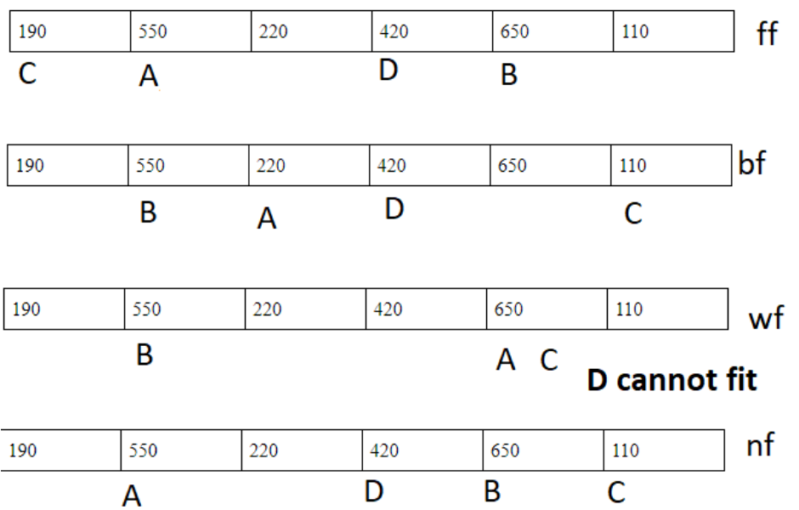

2. The 50% rule refers only to the number of holes and blocks, but not the amounts of memory space taken up by the holes and blocks. The amounts of space depend on the average hole size vs the average block size.

If k is the ratio between average hole size and average block size, then the fraction f of space occupied by holes can be determined using the formula f = k/(k + 2).

a. Determine the fraction of space wasted in holes if, on average, an occupied block is twice as large as a hole. (write the equation only.)

K = hole/block

In our case = hole/2*hole

k/(k+2) = (1/2)/(½ + 2) = 1/5

b. Determine the fraction of space wasted in holes if, on average, a hole is twice as large as an occupied block.

K = hole/block

In our case = 2*block/block

k/(k+2) = (2/4) = 1/2

3. Paging systems A through D use different combinations of pages sizes and address sizes:

|  | A | B | C | D |
| --- | --- | --- | --- | --- |
| Page size (# of words) | 512 | 1024 | 512 | 1024 |
| Logical address size (# of bits) | 16 | 16 | 32 | 32 |

For each system determine:

a. The page table size (Number of pages).

(logical space / page size) = page table size

For a = 128

For b = 64

For c = 8,388,608

For d = 4,194,304

b. The size of the logical address space (Number of words).

2^(logical address size)

For a = 65,536

For b = 65,536

For c = 4,294,967,296

For d = 4,294,967,296

4. Three functions, each of length 600 words, are linked together into one process and loaded into memory. Consider four possible combinations of paging and segmentation:

i. Paging (no segmentation):

page size: 1024 words

page table occupies 1 page

ii. Segmentation (no paging):

segment table size: 1024 words

iii. Segmentation with paging (each function becomes a separate segment):

page and segment size: 1024

page and segment tables occupy 1 page each

iv. Two-level paging (page table is paged):

page size: 1024

all page tables occupy 1 page each

CS3600 Spring 2021

a. For each system, determine the total amount of occupied memory space, including all page or segment tables.

1. 1024 + 3072 = 4092

Ii. 1024 + 1800 = 2824

Iii. 1024 + 3072+ 3072 = 7168

Iv. 1024 + 3072 + 3072 = 7168

b. For each system, determine the amount of space wasted due to internal

fragmentation.

1. 1350

Ii. 932

Iii. 2365

Iv. 2365

**What to turn in Canvas:**

Answers in a pdf document.